Case 13-US-IL-Bannerstone-Circular

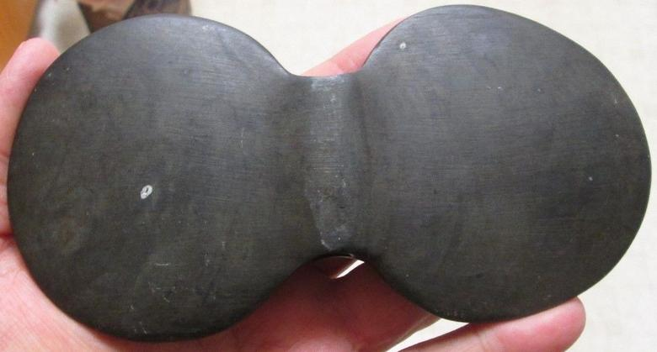Illinois 3 1/4 X 6 inches. slate.